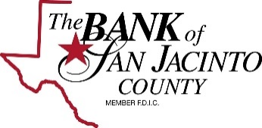

WIRING INSTRUCTIONS FOR
THE BANK OF SAN JACINTO COUNTY

Please wire loan pay off funds to:

The Bank of San Jacinto County
PO BOX 100 (Mailing Address)
100 St. Hwy. 150 (Physical Address)
Coldspring, TX 77331

ABA ROUTING# 113101524

Credit Account # on behalf of:
Customer:

Loan#:

